Shawna

Observations and Playtester Comments

# In-Game Observations

[Your thoughts as you watch the testers play]

* Not always able to find where to restart the game, but I guess this is the purpose that you need to explore

# In-Game Questions

Why did you make that choice? (to go into houses?)

* That’s what you always do in these kinds of games

Does that rule seem confusing? (choosing which choices mean what?)

* No I mean, this is a strategy game basically

What did you think that would do? (choosing one choice over another?)

* Yield different results on my stats

What is confusing for you?

* I want to be able to win, but I made the wrong choices in the beginning for fun

# Postgame Questions

[Questions you ask the testers as they have played]

* What did you think would happen at the end of the game?
  + Well, I did not win so I still don’t know what happens, but I believe you could leave the village
* Do you think if you played again, you would know how to win?
  + yes

## General Questions

What was your ﬁrst impression?

* The backstory was very well written, and was a cool storyline to follow

How did that impression change as you played?

* Still cool, just not as in depth

Was there anything you found frustrating?

* Not winning

Did the game drag at any point?

* no

Were there particular aspects that you found satisfying?

* The visuals were consistent throughout

What was the most exciting moment in the game?

* When I talked to the bunny

Did the game feel too long, too short, or just about right?

* Too short

## Formal Elements

Describe the objective of the game.

* Become more empathetic and do not be mean to people

Was the objective clear at all times?

* Yes, from the backstory and learning choices have an affect

What types of choices did you make during the game?

* Which choice I chose would get me better results

What was the most important decision you made?

* To go into houses to talk to people

What was your strategy for winning?

* In the beginning, I was just trying to be a little evil, but later I tried to win and was not able to

Did you ﬁnd any loopholes in the system?

* no

How would you describe the conﬂict?

* You were overthrown and now you need to become a better person

In what way did you interact with other players?

* NA

Do you prefer to play alone or with human opponents?

* With people

What elements do you think could be improved?

* Maybe a more in depth storyline

## Dramatic Elements

Was the game’s premise appealing to you?

* I prefer action over story really

Did the story enhance or detract from the game?

* enhanced

As you played, did the story evolve with the game?

* yes

Is this game appropriate for the target audience?

* yes

On a piece of paper, graph your emotional involvement over the course of the game.

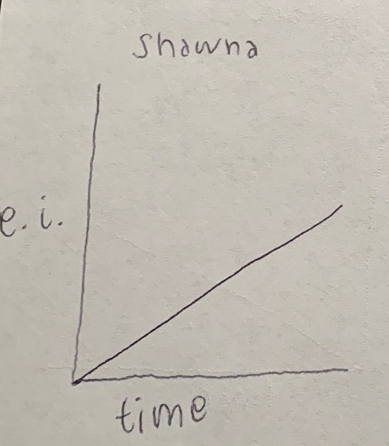

Did you feel a sense of dramatic climax as the game progressed?

* Not really

How would you make the story and game work better as a whole?

* More in depth storyline

## Procedures, rules, interface, and controls

Were the procedures and rules easy to understand?

* Yes, from title screens

How did the controls feel? Did they make sense?

* Same as any other game

Could you ﬁnd the information you needed on the interface?

* yes

Was there anything about the interface you would change?

* no

Did anything feel clunky, awkward, or confusing?

* no

Are there any controls or interface features you would like to see added?

* no

## End of Session

Overall, how would you describe this game’s appeal?

* Walking around and getting to look at nice visual arts, talking to these NPCs

Would you purchase this game?

* No, not enough action

What was missing from the game?

* A battle system or something

If you could change just one thing, what would it be?

* Adding a battle system

Who do you think is the target audience for this game?

* children

If you were to give this game as a gift, who would you give it to?

* My friend’s brother

# Revision Ideas

[Ideas you have for improving the game]

* Maybe add a screen for the restart option so people know it is there